Solano Opioid Overdose Snapshot: 2016-Q1 to 2018-Q4 Report downloaded 03-23-2020
Solano experienced 19 deaths due to all opioid-related overdoses in 2018, the most recent calendar year of data available. The annual crude mortality rate during that period was 4.3 per 100k residents. This represents a 25% increase from 2016. The following charts present 12-month moving averages and annualized quarterly rates for selected opioid indicators. Trend Data include the first quarter of 2019. The map displays the annual zip code level rates for all opioid-related overdoses. Synthetic opioid overdose deaths may be largely represented by fentanyl.
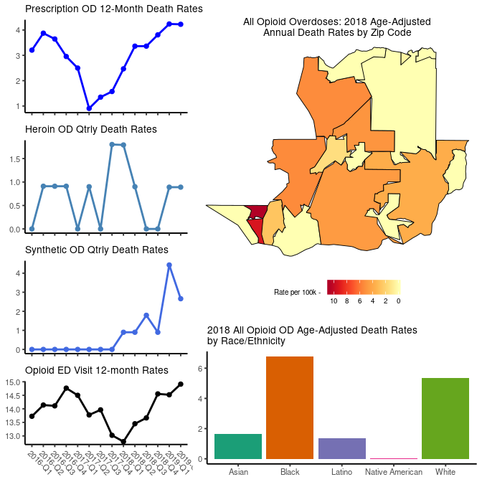

###Prescribing
There were 277,436 prescriptions for opioids in Solano in 2018, excluding buprenorphine. The annual crude prescribing rate during that period was 621.2 per 1,000 residents. This represents a 20% decrease in prescribing from 2016. The following charts present the annualized quarterly prescribing rates, MMEs (morphine milligram equivalents) per person per year, high dosage rate (i.e. greater than 90 Daily MMEs in the quarter), and the opioid/benzodiazepine overlap rate during 2018. Trend Data include the first quarter of 2019.
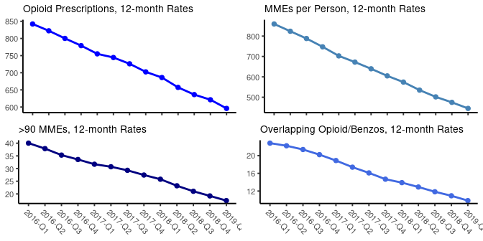
###Treatment
Buprenorphine prescriptions in the county are used to gauge the expansion of medication-assisted treatment (MAT). The annual crude buprenorphine prescribing rate in 2018 was 17.5 per 1,000 residents. This represents a 9% increase in buprenorphine prescribing from 2016. Trend Data include the first quarter of 2019.
