Solano Opioid Overdose Snapshot: 2017-Q1 through 2020-Q3
Report downloaded 08-12-2021
Solano experienced 34 any opioid-related overdose deaths in 2019, the most recent calendar year of data available and the annual crude mortality rate for 2019 was 7.53 per 100k residents. This represents a 235% increase from 2017. The following charts present 12-month moving averages for selected opioid indicators (prescription-, heroin-, and synthetic opioid-related overdose deaths, and ED visits related to any opioid) and include trend data for 2020*. The map displays the annual zip code level age-adjusted rates for all opioid-related overdoses. Synthetic opioid overdose deaths may be largely represented by fentanyl.
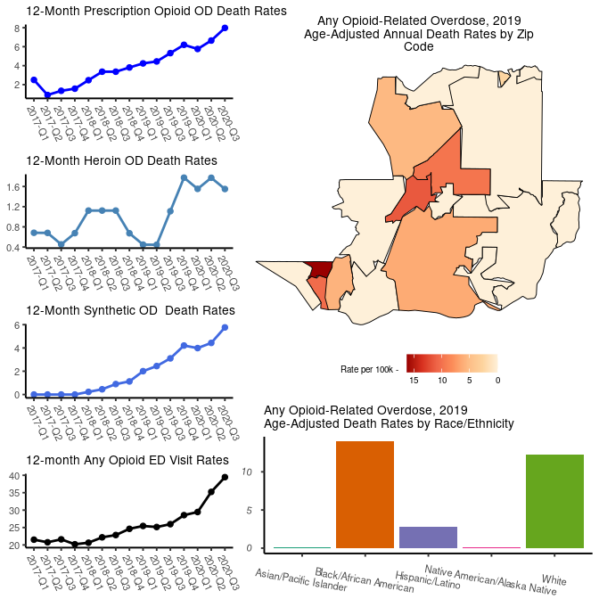

Prescribing
There were 243,541 prescriptions for opioids (excluding buprenorphine) in Solano in 2019. The annual crude opioid prescribing rate for 2019 was 544.05 per 1,000 residents. This represents a 23% decrease in prescribing from 2017. The following charts present 12-month moving averages for crude opioid prescribing rates, the crude rate of MMEs (morphine milligram equivalents) per person, the crude high dosage rate (i.e. greater than 90 Daily MMEs in the quarter), and the crude opioid/benzodiazepine overlap crude rate from 2017 to 2019 and include trend data for 2020*.

Treatment
Buprenorphine prescriptions in the county are used to gauge the expansion of medication-assisted treatment (MAT). The annual crude buprenorphine prescribing rate for 2019 was 17.8 per 1,000 residents. This represents a 2% decrease in buprenorphine prescribing from 2017.
